Handling Missing Data:  
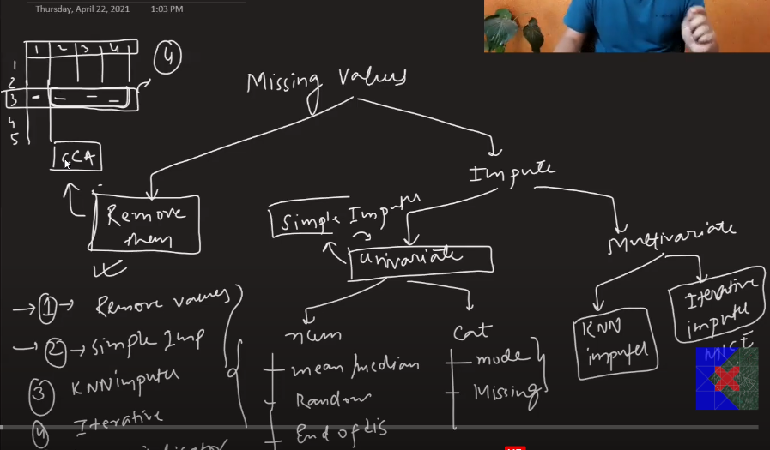

Complete Case Analysis : CCA means delete all the rows where we have missing values in the columns.

Assumption :

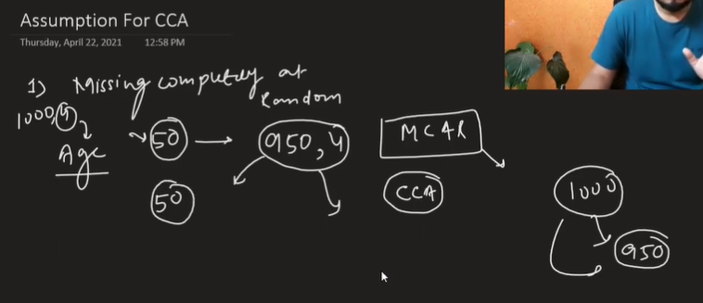

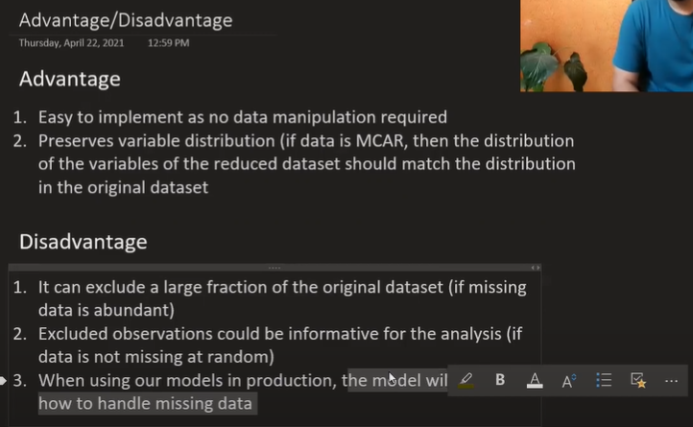

When to use CCA?

1.MCAR

2.5%